Lab Report No 5



Digital Signal Processing

Submitted By: **Muhammad Saad**

Registration No: **21PWCSE1997**

Section: **B**

“On my honor , as student of University of Engineering and Technology, I have neither given nor received unauthorized assistance on this academic work”

Student Signature:

Department of Computer Systems Engineering

University of Engineering and Technology Peshawar

**CSE 402L: Digital Signal Processing**

|  |  |  |  |  |
| --- | --- | --- | --- | --- |
| **Demonstration of Concepts** | **Poor (Does not meet expectation (1))**  The student failed to demonstrate a clear understanding of the assignment concepts | **Fair (Meet Expectation (2-3))**  The student demonstrated a clear understanding of some of the assignment concepts | **Good (Exceeds Expectation (4-5)**  The student demonstrated a clear understanding of the assignment concepts | **Score**  **30%** |
| **Accuracy** | The student completed ( <50%) tasks and provided MATLAB code and/or Simulink models with errors. Outputs shown are not correct in form of graphs (no labels) and/or tables along with incorrect analysis or remarks. | The student completed partial tasks (50% - <90%) with accurate MATLAB code and/or Simulink models. Correct outputs are shown in form of graphs (without labels) and/or tables along with correct analysis or remarks. | The student completed all required tasks (90%-100%) with accurate MATLAB code and/or Simulink models. Correct outputs are shown in form of labeled graphs and/or tables along with correct analysis or remarks. | **30%** |
| **Following Directions** | The student clearly failed to follow the verbal and written instructions to successfully complete the lab | The student failed to follow the some of the verbal and written instructions to successfully complete all requirements of the lab | The student followed the verbal and written instructions to successfully complete requirements of the lab | **20%** |
| **Time Utilization** | The student failed to complete even part of the lab in the allotted amount of time | The student failed to complete the entire lab in the allotted amount of time | The student completed the lab in its entirety in the allotted amount of time | **20%** |

Lab No: 5.

## Title: Spectral Analysis of a random signal using Matlab

Procedure:

1. **First create some data. Consider data sampled at 1000 samples/sec. Start by forming a time axis for the data, running from t=0 until t=.25 in steps of 1 millisecond. Then form a signal, x, containing sine waves at 50 Hz and 120 Hz.**

**(Hint: x = sin(2*pi*50*t) + sin(2*pi*120*t);)**

*%Task1*

t = 0 : 1/1000: 0.25;

sig = sin(2*pi*50*t) + sin(2*pi*120*t);

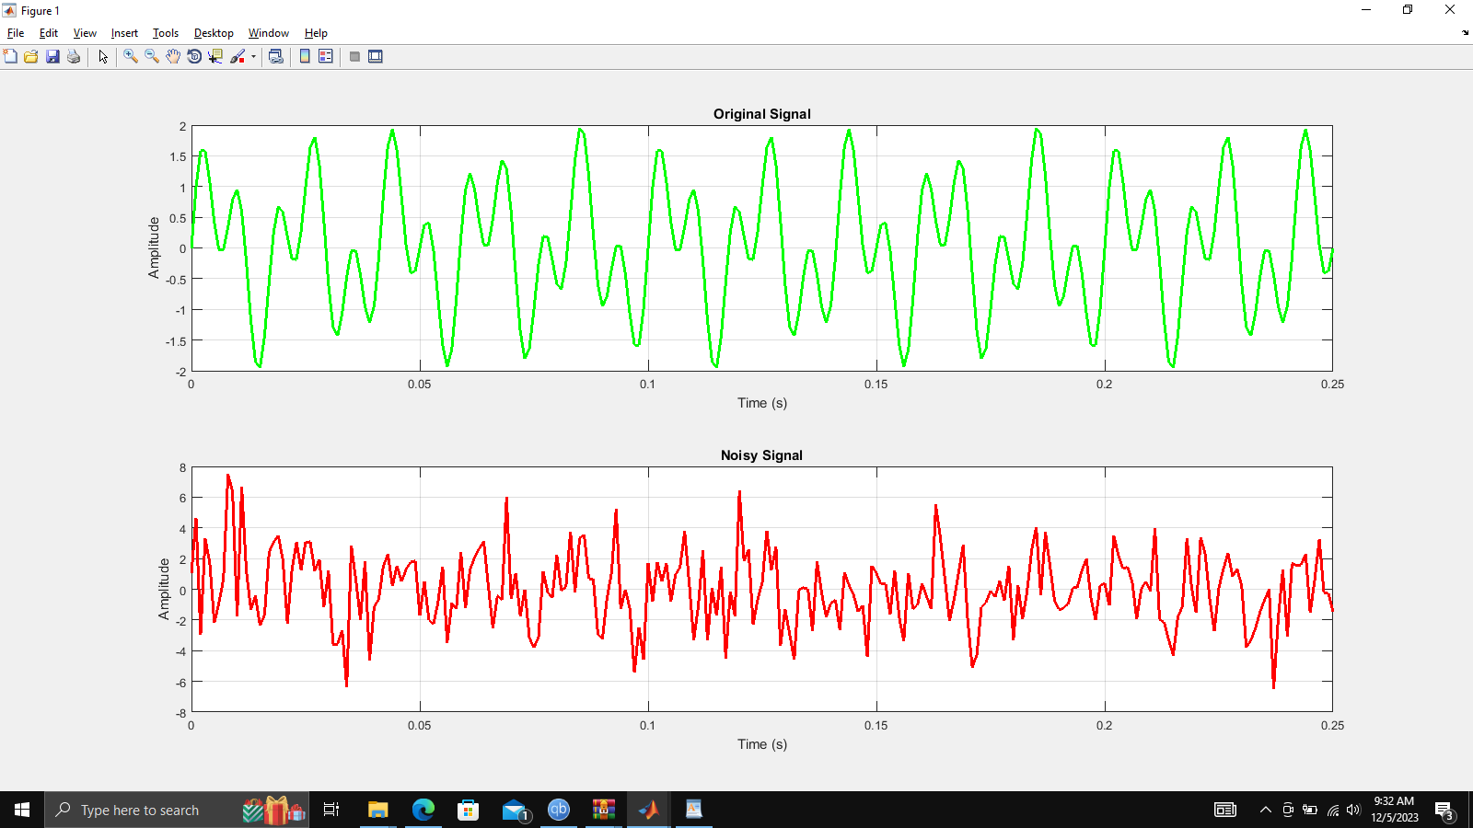

1. **Add some random noise with a standard deviation of 2 to produce a noisy signal y. Take a look at this noisy signal y by plotting it. (Hint: y = x + randn(size(t));)**

*%Task2*

noise = 0 + 2*randn(size(sig));

noisySignal = sig + noise;

figure

subplot(2,1,1);

plot(t, sig, 'g', 'LineWidth', 2);

title('Original Signal');

xlabel('Time (s)');

ylabel('Amplitude');

grid on;

subplot(2,1,2);

plot(t, noisySignal, 'r', 'LineWidth', 2);

title('Noisy Signal');

xlabel('Time (s)');

ylabel('Amplitude');

grid on;



1. **Finding the discrete Fourier transform of the noisy signal y (Hint: Y = fft(y,251);)**

*%Task3*

N = length(sig);

f = (-N/2:(N/2)-1)*1000/N;

figure

plot(f, fftshift(abs(fft(noisySignal, 251))), 'g');

title('Composite Signal Frequency Domain');

xlabel('Frequency (Hz)');

ylabel('Ampitude');

grid on;

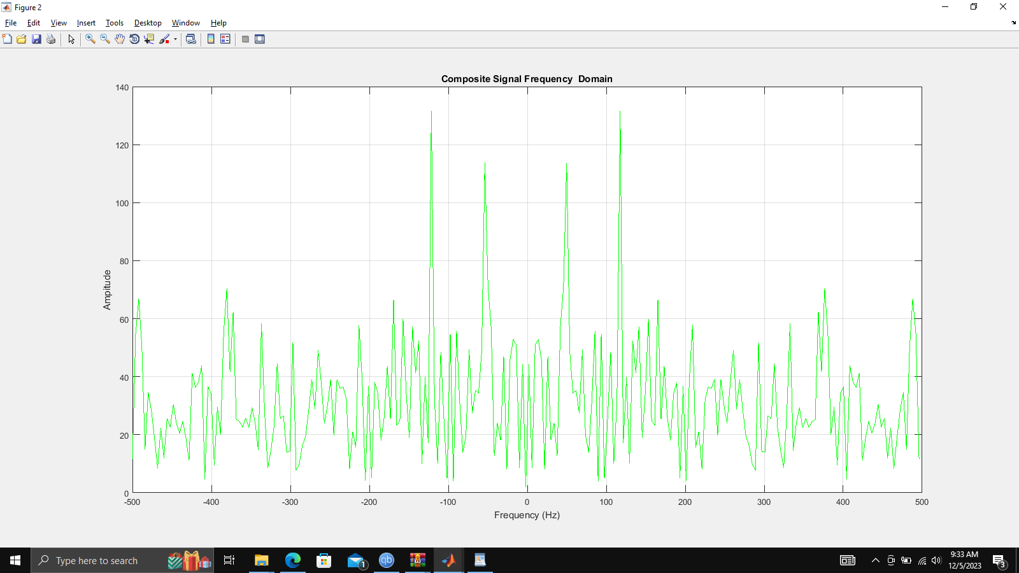

1. **Compute the power spectral density, a measurement of the energy at various frequencies, using the complex conjugate (CONJ). Form a frequency axis for the first 127 points and use it to plot the result.  (Hint: Pyy = Y.*conj(Y)/251; f = 1000/251*(0:127);)**

*%Task4*

Pyy = noisySignal.*conj(noisySignal)/251;

f1 = 1000/251*(0:127);

figure

plot(f, Pyy, 'r');

title('Power Spectral Density');

xlabel('Frequency (Hz)');

ylabel('Power (db/Hz)');

grid on;

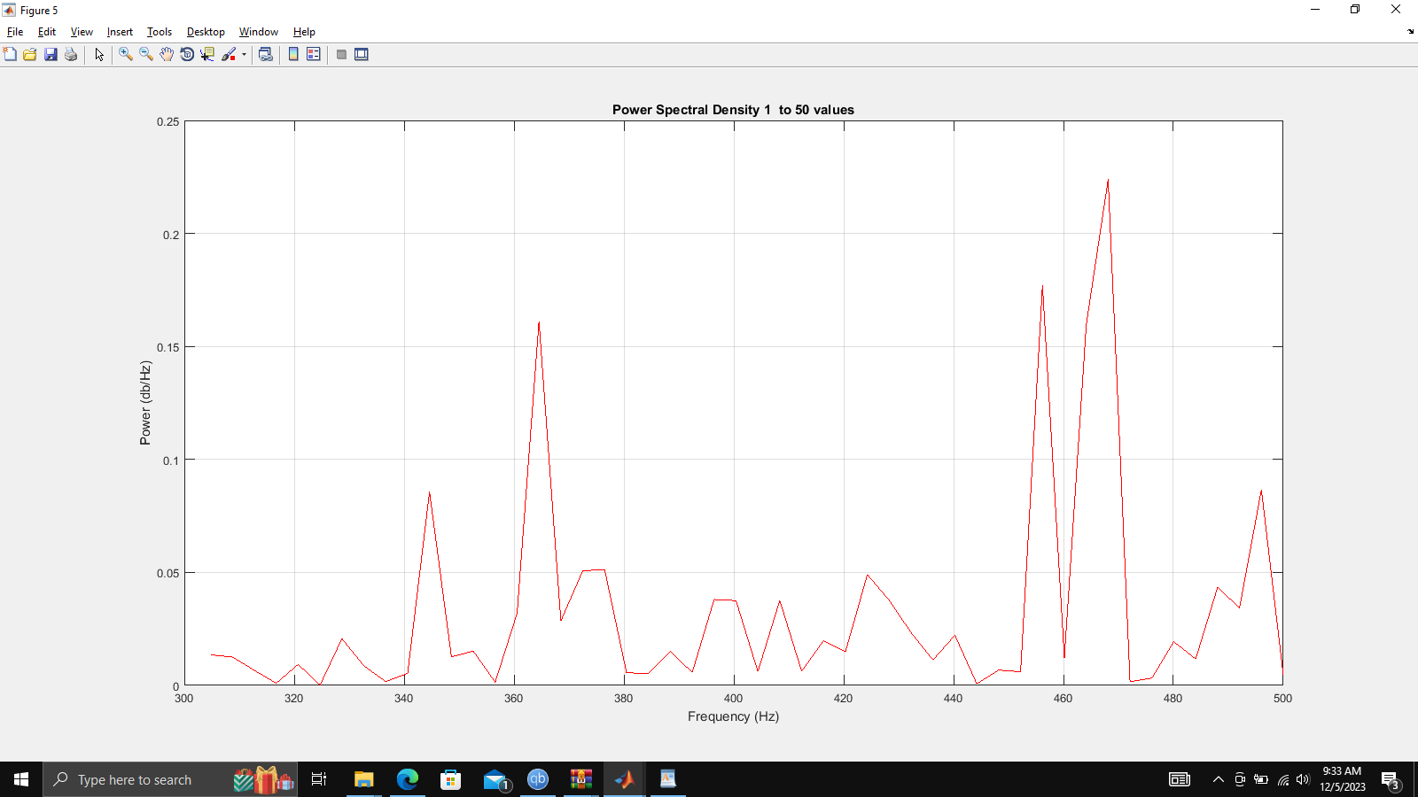

1. **Compute and plot the periodogram using periodogram. Show that the two results are identical.**

**[Pyy2,w] = periodogram(y,rectwin(length(y)),length(y),1000)**

**figure;**

**plot(w,10*log10(Pyy2))**

*%Task5*

[Pyy2, w] = periodogram(noisySignal, rectwin(length(noisySignal)), length(noisySignal), 1000);

figure

plot(w, 10*log10(Pyy2));

title('Periodogram Power Spectral Density');

xlabel('Frequency (Hz)');

ylabel('Power (db/Hz)');

grid on;

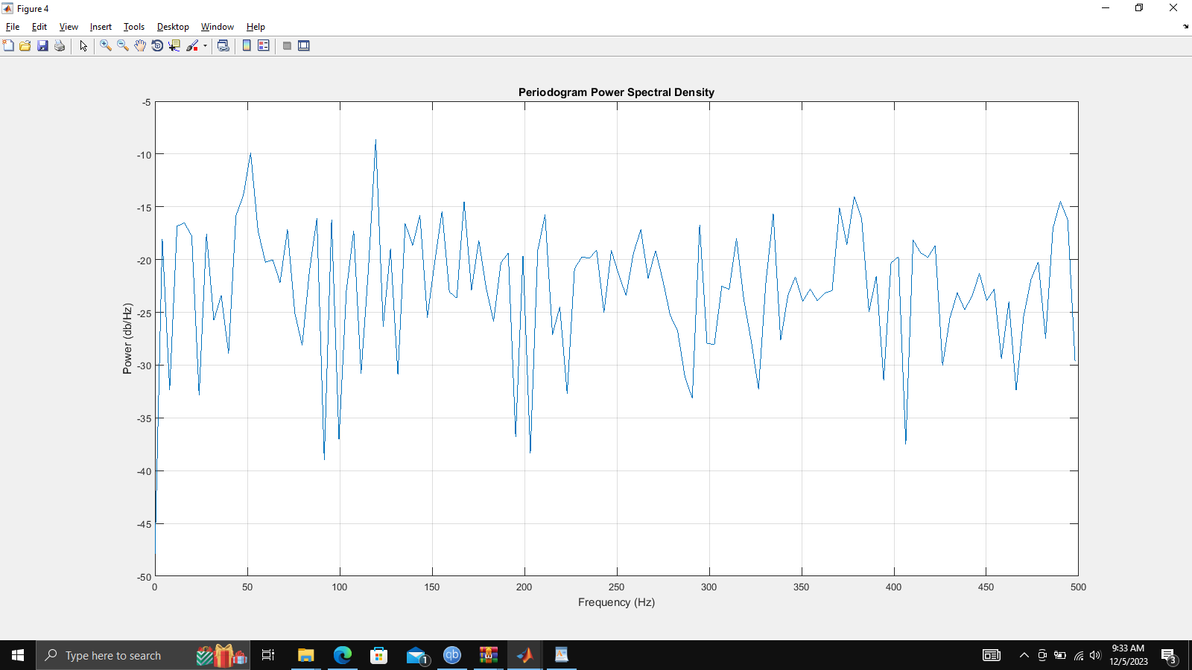

1. **Zoom in and plot only up to 200 Hz. No**

*%Task6*

figure

plot(abs(f(1:50)), Pyy(1:50), 'r');

title('Power Spectral Density 1 to 50 values');

xlabel('Frequency (Hz)');

ylabel('Power (db/Hz)');

grid on;



1. **Final Remarks/Conclusion.**

Power spectral analysis is a powerful tool that can be used to analyze random signals using Matlab. By utilizing the Fourier transform and Matlab's signal processing functions, it is possible to accurately measure the power spectral density of a signal and gain insight into its frequency content. In conclusion, power spectral analysis is an effective way to analyze random signals using Matlab and can be used to gain insight into the frequency content of the signal.

__________________________________________________________________________________________________